Aarti Paan, Dhruti Pandya, Matthew Posa, and Chuhui Qiu

Professor Morris Lancaster

CS6461 Section 10 Spring 2022

06 February 2022

**Group Project Phase 1 User Guide**

1. To start the simulator:
   1. If you are on Windows, double click “CSCI6461_Project_main.exe” to start the compiled executable;
   2. If you are not on Windows but have Python version 3.7 or higher installed, run “CSCI6461_Project_main.py” from Python to start the program.
2. Main Interface:

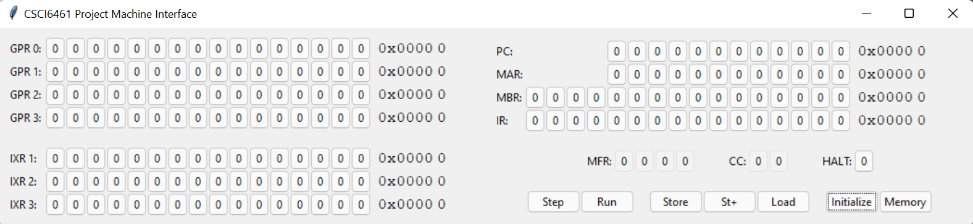

1. You should see an interface similar to the picture above.
2. All registers are big-Endian, meaning that bits on the left are the most significant bits.
3. Unlike other simulator implementations you may have seen, there are no dedicated “Switches” or “LD” buttons, instead, to change the value of a register, you simply click on the displayed “0” or “1” buttons to toggle them. The numbers on the right of the buttons are hexadecimal and decimal displays to help you read the current value of the register.
4. Not all registers are editable, some buttons are grayed-out, meaning they are read-only.
5. The GPR 0-3 are the “General Purpose Registers” numbering 0-3 to hold general data. The IXR 1-3 are the “Index Registers” numbering 1-3 to hold memory address index data.
6. The PC is the “Program Counter” which holds the address of the instruction to be executed.
7. The MAR is the “Memory Address Register” which holds an address to look up from the program’s memory.
8. The MBR is the “Memory Buffer Register” which holds data read from or to be written to the memory.
9. The IR is the “Instruction Register” which holds the instruction that is currently being executed or has been executed.
10. The MFR is the “Machine Fault Register” to warn user of faults:
    1. 0001 is “Illegal Memory Address: Reserved Location”, which occurs when a user tries to write to a reserved location.
    2. 0010 is “Illegal Trap code”; it is currently not implemented.
    3. 0100 is “Illegal Operation Code”, which occurs when an unknown operation is executed.
    4. 1000 is “Illegal Memory Address: memory installed”, which occurs when the memory address is greater than the machine’s capacity (0 to 2047).
11. The CC is the “Condition Code” for arithmetic and logical operations, since no such operation is implemented yet, this currently does nothing.
12. The HLT is the “Machine Status Indicator”, it is 1 if the machine is halted (at which point no instruction can be executed), it can be manually toggled back to 0 to resume the machine.
13. The Step button is used to step the machine a single time, it would load the instruction pointed to by the PC to execute, then increment PC by 1.
14. The Run button is used to continuously execute instructions, this repeats until the machine halts.
15. The Store/St+/Load/Initialize/Memory buttons are explained below.
16. How to Load/Store information from/into the memory: 3 different ways
    1. You may use any of the three methods listed below:
       1. The slow, “orthodox” way with MAR and MBR: First click on the buttons of MAR registers to set the memory word address you want to load/store from/to, then similarly set MBR if you want to store the data. Then you can click the “Load” button to load the data from memory[MAR] into MBR, or you can click “Store” to store data from MBR into memory[MAR]. “St+” is similar to Store, but it also increments MAR to allow repeated storing.
       2. The faster way–“Initialize” by file: First click on the “Initialize” button, it will open a file prompt for you to choose a file. The file should be a plain text file (not rich text, json, xml, or word document), each line of the file should contain two hexadecimal numbers separated by a whitespace, the first number would represent a memory address while the second would contain the value to be stored. Once the file is chosen, the program will automatically read its content and write the memory as specified by the file. It will also reset all interface registers to 0. This can only store value into the memory, not load from them.
       3. The customizable, visualizable way with “Memory”: click on “Memory” Button, you would see a separate window open. See below.
17. Memory Interface
    1. The top of the window is a page navigation register in which you can choose the memory address you want to access. Then the 16 registers below will update to show the content of the next 16 words starting from the chosen memory location. You can click on any of the 16 lower registers to edit the words, and the changes will be immediately applied to the memory.
    2. The “Memory” Button on the main interface will be disabled if a memory interface window is already open, only a single memory interface window can be open at a time.

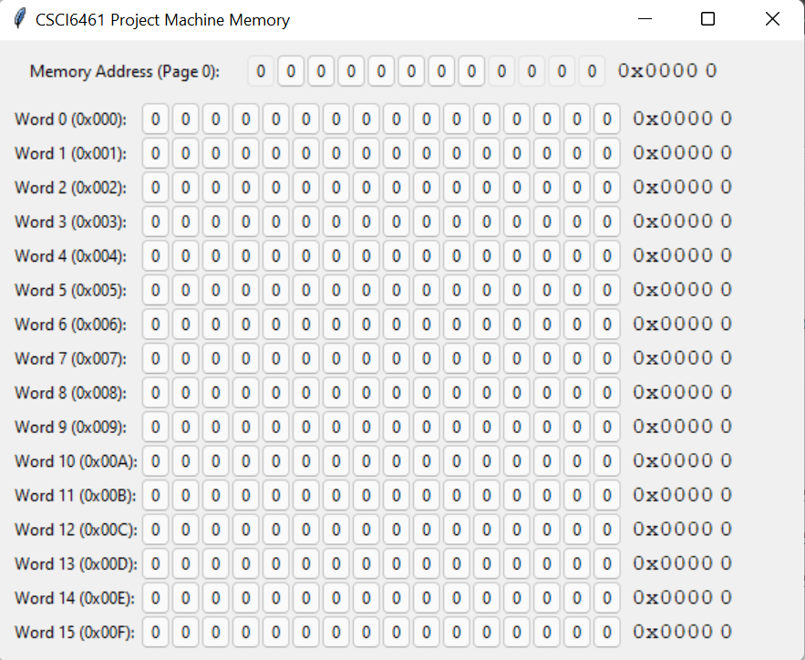

1. How to execute a loaded program:
   1. Currently, only 6 instructions are recognized (opcode are in parentheses): HLT(0)/LDR(1)/LDA(2)/LDX(3)/STR(33)/STX(34)
   2. First, load the memory as instructed above.
   3. Then, make sure the HLT register on the interface is 0, toggle it if necessary.
   4. Next, manually click on the buttons of the PC register, so that it points to the beginning of your program in memory.
   5. Then you may do either of the following:
      1. Clicking “Step” will step the simulated program exactly once, so one instruction will be executed, and PC will automatically increment by 1 to the next instruction (unless the previous instruction is a HLT)
      2. Clicking “Run” will repeatedly step the program, until a HLT instruction is executed.
   6. When a HLT instruction is executed, the HLT register on the interface will become 1 (“stopped”) and no more instructions will be executed.
   7. You may then inspect the registers directly, as well as the memory (with either Load button or the Memory Interface) to view the result of the execution.
2. What if the user made a mistake when operating the simulator?
   1. A “revert” functionality is planned but not implemented yet, the only current way is to click “Initialize” to reset the memory and registers, to start again.
3. How to close the memory interface?
   1. Simply click the “x” on the top right corner of the memory interface window, all changes are saved in the memory.
   2. Closing the memory interface window will enable the “Memory” button on the main Interface window.
4. How to quit the program?
   1. Simply click the “x” on the top right corner of the main interface window; special handlers have already been set up to gracefully cleanup and quit the simulator program.